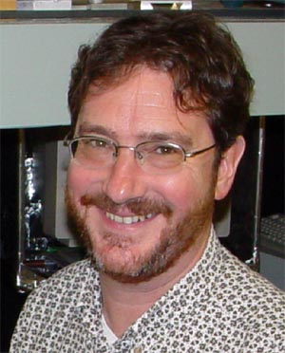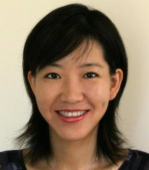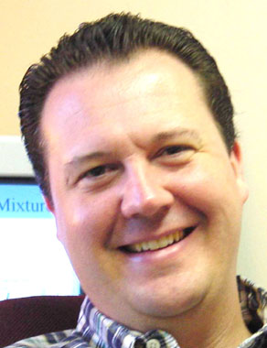
Stefan Franzen, Ph. D. Lin He, Ph. D. Christopher Gorman, Ph. D.
Professor of Chemistry Asst. Professor of Chemistry Professor of Chemistry
Stefan_Franzen@ncsu.edu Lin_He@ncsu.edu Chris_Gorman@ncsu.edu

Join Us in Discovery

On-Campus Interviews for Admission to Graduate Program in Chemistry

North Carolina State University
(http://www.ncsu.edu/chemistry/)

Time: 14: 30
Friday, October 20, 2006

Place: Zhejiang University
教八－515

Instructions for Interview

- The meeting will begin with a brief introduction to the University and Department.
- Professors Gorman, Franzen, and He will be happy to answer any questions you have about the program.
- A sign up sheet will be available for individual interviews.
- For your interview, please bring unofficial copies of your transcripts, GRE and TOEFL scores
- Interviews will be informal conversations about your undergraduate work.

If you have any questions, please email Professor Gorman

A printed copy of the graduate program description is available from:

Professor Lou Hui

