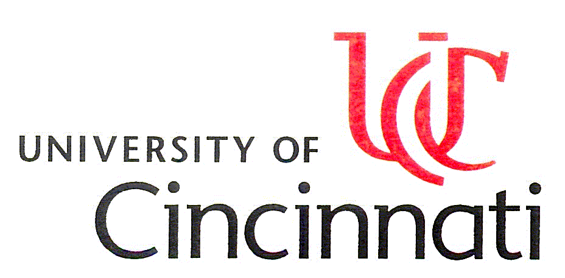
Department of Chemical and Materials Engineering



Dr. Wim J. van Ooij
Professor 1

- Editor-in-Chief Journal of Adhesion Science and Technology (1987-to date)
- Editorial Board Plasmas and Polymers (1994-to date)
- Editorial Board Progress in Organic Coatings (1987-to date)
- Editorial Board Surface and Interface Analysis (1985-1987)
Current Research Interests:
Adhesion Science; Polymer-Metal Interfaces; Corrosion; Electrochemistry; Time-of-Flight SIMS; Surface Analysis; Plasma Polymerization; Surface Modification of Materials; Chemistry of Organofunctional Silanes at Metal Surfaces and in Solution
Lecture title:
“Novel, chromate-free metal anti-corrosion pretreatments and primers based on organofunctional silanes”

Place and date:
Room 107, teaching building No. 8, Yuquan campus, Zhejiang University, 9:00 am, Nov. 24, 2006
Correspondent:
Associate professor Ji-Ming Hu. Tel: 87952318; Email address: kejmhu@zju.edu.cn

