**NUS CHEMICAL TECHNOLOGY SUMMER SCHOOL**

**20 – 31 July 2020**

The Chemical Technology Summer School is offered by the National University of Singapore (NUS), Department of Chemical & Biomolecular Engineering. This is a two-week online learning programme on modern chemical technologies, including instrumental methods, nanotechnology and modern organic chemistry. Students will attend online lectures conducted in English by specially identified professors from one of the top Universities in the world. Our experiential teaching practice is internationally-renowned. This programme comprises lectures, practical anecdotes and case studies, group discussions and presentations. Through the two-weeks of e-learning on customized topics, students will gain an international academic experience in a top university.

NUS Department of Chemical & Biomolecular Engineering is one of the major players in advancing the chemical engineering discipline to solve pressing problems facing mankind today, with a truly Singaporean spirit of growth, innovation and enterprise. Attracting the best students from Singapore and the region, with faculty members coming from the most renowned Universities around the world, we provide a combination of world-class cutting edge research, educational practice, and opportunities for undergraduates, graduates and working adults to up-scale their skills and knowledge; to help companies and industries enhance the value of their workforce to stay relevant and competitive; and to support the country’s manpower needs. The prestige and hallmark of the NUS brand as Asia's leading university is globally recognized. NUS is ranked 1st in Singapore & Asia Pacific, and 11th in the world according to the 2020 QS World University Rankings; NUS Chemical Engineering is ranked 8th in the 2020 QS World University Rankings by Subject in Chemical Engineering. Together with our passionate academia and cutting-edge technologies, we are committed to providing you with an enriching and stimulating online learning experience this summer!

**DURATION:** 2 weeks, Monday – Friday

**CONTENT:**

|  |  |  |
| --- | --- | --- |
| **Topic** | **Trainer** | **Format** |
| 1. Advances and Opportunities in Chemical Science & Technology | [A/P Saif Khan](https://www.eng.nus.edu.sg/chbe/staff/chesakk/) | 1 session seminar |
| 1. Chemical Process Safety | [A/P Ivan Sin](https://www.eng.nus.edu.sg/chbe/staff/sin-siang-meng-ivan/) | 1 session lecture |
| 1. Towards a Zero Waste Circular Economy | [A/P Yan Ning](https://www.eng.nus.edu.sg/chbe/staff/cheyann/) | 1 session seminar |
| 1. MOFs & Polymers | [A/P Zhao Dan](https://www.eng.nus.edu.sg/chbe/staff/chezhao/) | 1 session seminar |
| 1. Chemistry in Nanomedicines | [A/P David Leong](https://www.eng.nus.edu.sg/chbe/staff/cheltwd/) | 1 session seminar |
| 1. Analytical Chemistry (Spectroscopy and Instrumentation) | [A/P Yang Kun-Lin](https://www.eng.nus.edu.sg/chbe/staff/cheyk/) | 3 sessions lectures/assessment |
| 1. From Cells to Vials: The Story of Biopharmaceutical Manufacture | [Dr Satyen Gautam](https://www.eng.nus.edu.sg/chbe/staff/chesaty/) | 3 sessions lectures/assessment |
| 1. Polymer Engineering and Drug Delivery | [A/P Tong Yen Wah](https://www.eng.nus.edu.sg/chbe/staff/chetyw/) | 3 sessions lectures/assessment |
| 1. Cellular Metabolism and Drug Manufacturing | [Dr Zhou Kang](https://www.eng.nus.edu.sg/chbe/staff/chezkg/) | 3 sessions lectures/assessment |
| 1. Presentation Skills Workshop | [A/P Loh Kai Chee](https://www.eng.nus.edu.sg/chbe/staff/chelohkc/) | 2 sessions lecture +  1 session group discussion/presentation |

**DAILY SCHEDULE:**

|  |  |  |  |
| --- | --- | --- | --- |
| **Morning Session** | | **Afternoon Session** | |
| 0900 – 1015 | eLearning | 1400 – 1515 | eLearning |
| 1015 – 1030 | Break | 1515 – 1530 | Break |
| 1030 – 1145 | eLearning | 1530 – 1645 | eLearning |
| 1145 – 1200 | Q&A | 1645 – 1700 | Q&A |

**TRAINING OUTLINE AND TRAINERS PROFILE**

**Advances and Opportunities in Chemical Science & Technology**

Trainer: [A/P Saif Khan](https://www.eng.nus.edu.sg/chbe/staff/chesakk/)

In this seminar, we will take an in depth look at some of the latest advances in the chemical sciences and technology, in the areas of energy/sustainability, healthcare, advanced manufacturing and AI/automation. Modern chemical engineering is a frontier discipline for the future, and uniquely encompasses concepts and phenomena that span vast scales, from molecular sensors for coronavirus diagnosis to global climate change. This seminar will highlight the breadth of chemical science research, including (but not limited to) topics such as  advanced materials design at the molecular scale for energy applications, sensors and diagnostics for healthcare and advanced, self-optimizing continuous flow manufacturing systems integrated with machine learning. New opportunities for cross-disciplinary research will also be discussed throughout the seminar.

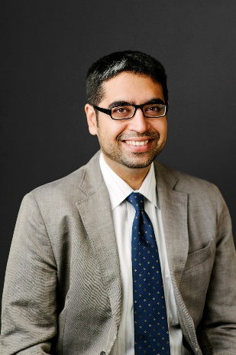Dr. Saif A. Khan is currently Deputy Head (Research) and an Associate Professor of Chemical and Biomolecular Engineering at NUS, where he teaches a range of topics including chemical reaction engineering, chemical engineering principles, numerical methods and computer programming. He obtained a Bachelor degree in Chemical Engineering at the University Department of Chemical Technology (UDCT), Mumbai where he was the university gold medalist. He received his Ph.D. in Chemical Engineering from the Massachusetts Institute of Technology in 2006, where he was a Presidential Fellow. His research group at NUS develops new microfluidics‐based ‘factories’ for the continuous manufacture of pharmaceuticals and advanced materials in collaboration with several industrial partners worldwide. He has co‐founded two start‐up companies focused on lipid‐based encapsulation systems and ophthalmic drug delivery, respectively. Dr. Khan is also the Chair of the General Education Committee at NUS, which cuts across all faculties in the University, and a three-time recipient of the Annual Teaching Excellence Award at NUS.

**Chemical Process Safety**

Trainer: [A/P Ivan Sin](https://www.eng.nus.edu.sg/chbe/staff/sin-siang-meng-ivan/)

As we gain domain scientific knowledge in our specialized areas of study, we also need to recognize that many of these materials/chemicals are highly hazardous that poses safety and health concerns to both chemical handlers and chemical processing facilities – your future work environment. To ensure a safe and healthful work environment, chemical processing facilities are required to implement effective Process Safety Management (PSM) to manage the associated hazards in the handling and processing of these hazardous chemicals. This is an industry-orientated session to introduce the fundamentals of chemical process safety and acquaint the participants with the required process safety principles, concepts, methods and tools for identifying, analyzing, and controlling process hazards and their associated impact on safety, health and the environment. Participants will learn how the industries implement PSM, safe work practices, and risk management procedures that are necessary to prevent releases and exposures in the workplace and the community. We will also take a quick look at how safe plant operations will evolve in the new future with the Industry 4.0 revolution, and how Data Technology (Not Information Technology, Not Digital Technology) with new drivers such as Big Data, Industrial Internet of Things (IIoT), Machine Learning and Artificial Intelligence will shape the future of chemical plant operations – Allowing You to Join the Industry More Informed!

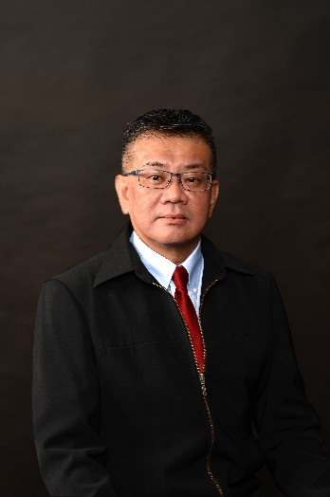Dr. Ivan Sin is the Safety, Health and Environment Programme Director and an Associate Professor at NUS Department of Chemical & Biomolecular Engineering. As a certified emergency responder, planner, fire and explosion investigator, and commander, he has 25 years of experience in the areas of safety and health, with focus in fire safety, emergency response, incident investigation, business continuity, disaster recovery, and crisis management with the Singapore Civil Defence Force (SCDF) and the Monetary Authority of Singapore (MAS). As a member of the Technical Committee for Petroleum Processes and Products, SPRING Singapore and Council Member of the Society of Loss Prevention for Process Industries (SLP), he is experienced and well-received in project consulting and training for clienteles in emergency incident, business continuity and crisis management; including conducts of validation tabletop and deployment exercises at different corporate levels, such as Pertamina PHE Head Office, Shell Jurong Island, Roche Pharmaceuticals, Iron Mountain Information (Former Recall Corporation), and TPSC Asia (Former Total Petrochemicals).

**Towards a Zero Waste Circular Economy**

Trainer: [A/P Yan Ning](https://www.eng.nus.edu.sg/chbe/staff/cheyann/)

In this seminar, students will be introduced to the key concepts of a zero waste cycle economy, i.e., reduce, reuse and recycle, to minimize and eventually diminish the production of wastes. Included in our discussion are existing projects at the pilot scale in various countries, as well as a lead towards future trends.

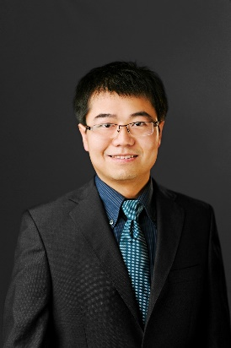Dr. Yan Ning is **a**n Associate Professor at NUS Department of Chemical & Biomolecular Engineering. He obtained his Bachelor and PhD degrees from Peking University in 2004 and 2009, respectively. After working as a Marie-Curie Research Fellow at Ecole Polytechnique Federale de Lausanne, Switzerland, he joined the NUS and established the Lab of Green Catalysis in 2012. His major research interests include catalytic biomass conversion, green chemistry & engineering, and catalyst development. He is a winner of several research awards, such as the RSC Environment, Sustainability and Energy Division Early Career Award (2017), the ACS Sustainable Chemistry & Engineering Lectureship Award (2018), and the NUS Young Researcher Award (2019).

**MOFs & Polymers**

Trainer: [A/P Zhao Dan](https://www.eng.nus.edu.sg/chbe/staff/chezhao/)

Metal-organic frameworks (MOFs), which represent a new frontier of materials research, are coordination polymers consisting of metal ions/clusters as nodes and organic ligands as spacers. Possessing the merits of both inorganic and organic building units, MOFs can fill a niche in the search for new porous materials and have found wide applications in gas storage, adsorption-based gas/vapor separation, shape/size-selective catalysis, and as templates/precursors in the preparation of other porous materials. In this lecture, the structure, chemistry, and typical applications of MOFs, with a focus on gas storage and separation, will be discussed.

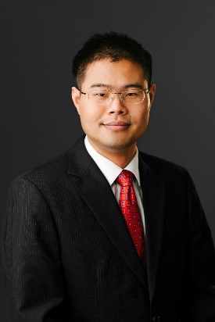Dr. Zhao Dan is an Associate Professor at NUS Department of Chemical & Biomolecular Engineering. He obtained his PhD degree in Inorganic Chemistry under the supervision of Prof. Hong-Cai Joe Zhou at Texas A&M University in 2010. After finishing his postdoctoral training at Argonne National Laboratory, he joined NUS in July 2012 as an Assistant Professor, and was promoted to Associate Professor with tenure in July 2018. His research interests include advanced porous materials and membranes with particular applications in clean energy and environmental sustainability. He has been awarded teaching commendation awards in AY2014/2015 and AY2017/18.

**Chemistry in Nanomedicines**

Trainer: [A/P David Leong](https://www.eng.nus.edu.sg/chbe/staff/cheltwd/)

Man has been plagued with diseases throughout our known history. Epidemic plagues of cataclysmic proportions caused by infectious organisms have almost wiped out the entire world’s population. In recent years, with improved living standards worldwide, citizens in developed countries also begin to suffer from resources rich diseases like metabolic diseases. While the picture seemed a bit bleak, technology in recent decades has also caught up with solving some of mankind’s biggest diseases, resulting in increased life expectancy. Nanotechnology holds much promise as a high precision toolkit to be part of these solutions. Nanotechnology here can be a multidisciplinary product of chemistry, biology, medicine and physics in the form of stimuli responsive drug carriers, as high specificity bioimaging tools, molecular and supramolecular scale devices with almost science fictional capabilities. Due to their nanoscale, nanomaterials also carry new chemical, physical and biological properties which can be exploited for therapeutic endpoints. This seminar will introduce and explain the underlying principles behind these nanomaterials’ properties and expound on actual applications of these exciting biomedical nanotechnologies. The advantageous insights into these biomedical nanomaterials will be balanced with insights into their unexpected and sometimes toxic effects. Students will be treated to a very good overview of biomedical nanotechnologies in preparation for future industrial and academic training in this exciting area of research.

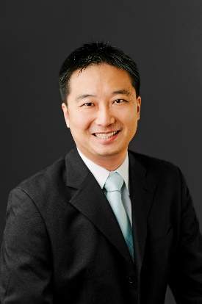

Dr. David Leong is an Associate Professor at NUS Department of Chemical and Biomolecular Engineering. He obtained his PhD in Biology and Bachelor in Chemical Engineering from NUS and was trained in Howard Hughes Medical Institute at the University of Pennsylvania as a postdoc fellow. He was a recipient of the prestigious Lee Kuan Yew Fellowship and recently elected into the Royal Society of Chemistry as a Fellow. His research expertise is in the area of bionanotechnology and nanotoxicology. He teaches several modules related to toxicology, process safety and bionanotechnology. He has published more than 130 papers (h-index of 50 with total citations of more than 7380) in top journals like Nature Nanotechnology, Nature Communications, Chemical Society Reviews, ACS Nano, Nano Letters, Advanced Functional Materials, Chemistry of Materials, ACS Applied Materials and Interfaces, Biomaterials and Nanotoxicology.

**Analytical Chemistry (Spectroscopy and Instrumentation)**

Trainer: [A/P Yang Kun-Lin](https://www.eng.nus.edu.sg/chbe/staff/cheyk/)

Chemical bonds vibrate like a spring at certain frequencies. The fundamental frequency provides crucial information about the chemical bond and the molecules. Modern instrumentation including Fourier Transform Infrared (FT-IR) spectroscopy, FT-Raman spectroscopy and nuclear magnetic resonance spectroscopy (NMR) are essential tools for us to understand these chemical bonds in detail. In this session, students will learn how to apply these techniques to characterize organic molecules and their functional groups. Some case studies will be provided to explain how molecular spectroscopy is used in chemical and pharmaceutical industries to solve practical problems.

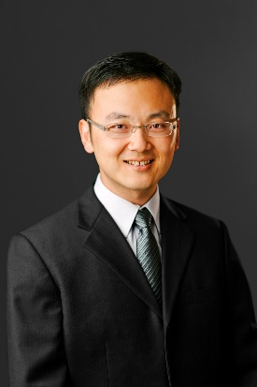Dr. Yang Kun-Lin is Deputy Head (Students & Academic Affairs) and an Associate Professor at NUS Department of Chemical and Biomolecular Engineering. Before joining NUS, he was a post-doctoral researcher in the Chemical and Biomolecular Department at the University of Wisconsin - Madison. He received his PhD degree from Georgia Institute of Technology in 2002. He is the recipient of Defense Innovation Research Program Award in 2009, A*STAR Research Grant Awards in 2006, 2008 and 2015 for his work on microfluidics – liquid crystal sensors and TechConnect Award for his solid-state fermentation technology. His present research interests include biosensors, liquid crystals, microfluidics, and microbes for molecules. He is also a winner of several teaching awards, including the NUS Annual Teaching Excellence Award (ATEA) in 2013, 2014 and 2015, and is currently an inductee in the ATEA Honors Roll.

**From Cells to Vials: The Story of Biopharmaceutical Manufacture**

Trainer: [Dr Satyen Gautam](https://www.eng.nus.edu.sg/chbe/staff/chesaty/)

This two-part lesson provides students with a broad overview of protein-based biologics and its manufacturing operation. The first part discusses the four major steps in the production of therapeutic proteins namely cell bank production, upstream processing, downstream processing and formulation, fill & finish. The second part gives students an understanding of quality control in biopharmaceutical manufacture and introduces them to the various analytical techniques used to evaluate the quality control attributes of therapeutic proteins.

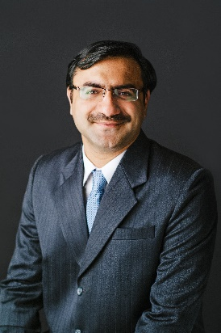.

Dr. Satyen Gautamis currently a Senior Lecturer at the NUS Department of Chemical and Biomolecular Engineering. He earned his PhD in Chemical Engineering from NUS in 2011. He teaches courses in kinetics, food technology, process design, and biotechnology. Recipient of the Engineering Educator Award Honor Roll and Annual Teaching Excellence Award Honour Roll, Dr Satyen is enthusiastic about the use of technology in teaching & learning and promoting student engagement in learning.

**Polymer Engineering and Drug Delivery**

Trainer: [A/P Tong Yen Wah](https://www.eng.nus.edu.sg/chbe/staff/chetyw/)

The first part of this session on Polymer Engineering covers the survey of different polymers obtained biologically, their properties, synthesis and application. Students will learn basic polymer nomenclature and chemistry specifically for biopolymers. Concepts in polymerization, polymer modification and polymer engineering will also be introduced. The use of biopolymers for tissue engineering will be used as a case study. The second part on Drug Delivery will apply engineering principles to solve problems in drug delivery and the design of advanced drug delivery devices. Students will learn basic mass transfer in designing drug delivery systems for human healthcare. Concepts in system physiology, pharmacokinetics and pharmacodynamics will be introduced quickly. The release of drug molecules from polymer-based systems will be used as a case study.

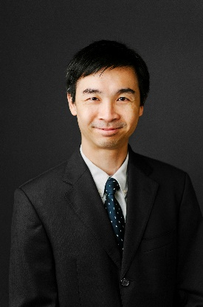Dr. Tong Yen Wah is an Associate Professor at NUS Department of Chemical and Biomolecular Engineering. He joined NUS after graduating from the University of Toronto with a PhD in Chemical Engineering in 2001. His expertise is in biomaterials research for tissue engineering and in bioenergy from food wastes and biomass wastes, with over 130 publications and 6000 citations. He has also done work on protein and virus capture using molecular imprinting on polymeric nanoparticles, for prevention of viral infections and for biomolecule production. His recent works in food wastes management has been successfully commercialized with distributed anaerobic digesters that can be effectively used in cities through a spin-off company from NUS.  Dr. Tong is currently the co-Programme Director for a NRF CREATE programme with Shanghai Jiao Tong University (SJTU) on “Energy and Environmental Sustainability Solutions for Megacities”, E2S2-CREATE, a collaborative research programme between NUS and SJTU funded by the Singapore National Research Foundation for S$89 million on studying coupled problems in megacities related to energy, environment, health and waste. He is the Assistant Dean in the Research Office for the Faculty of Engineering and is also on the Executive Committee for the NUS Environment Research Institute. Dr. Tong won the NUS Annual Teaching Excellence Award from 2005 to 2008 and has been inducted into the NUS Annual Teaching Excellence Honor Roll in 2008. He was awarded the Engineering Educator Award in 2005 and has been on the Faculty of Engineering Teaching Excellence Honours list for multiple years.

**Cellular Metabolism and Drug Manufacturing**

Trainer: [Dr Zhou Kang](https://www.eng.nus.edu.sg/chbe/staff/chezkg/)

Microbial fermentation is an emerging technology for manufacturing drugs and value-added chemicals, due to the advances in genetic engineering tools and our understanding of cellular metabolism. This technology can potentially produce a myriad of products at a lower cost and/or from renewable resources. In three sessions, students will be introduced a) how cells derive energy and use them to synthesize their own biomass; b) principles of important genetic engineering tools; c) the tools to divert cellular energy and building blocks of biomass to synthesize molecules of interest, all of which will be exemplified with representative case studies.

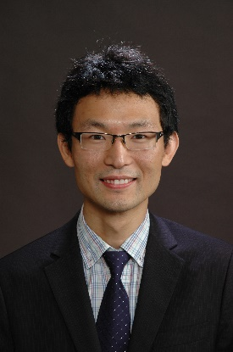Dr. Zhou Kang is an Assistant Professor at NUS Department of Chemical and Biomolecular Engineering. He obtained his Bachelor degree from Tianjin University in 2007 and his PhD degree from Singapore-MIT Alliance in 2012. He subsequently did his postdoctoral research work at MIT and then joined NUS in 2015. His current research interest focusses on engineering microbial metabolism to convert cheap, renewable substrates into more valuable products. He teaches numerical methods at undergraduate level and Bioinformatics and Applied Molecular Biology at graduate level. He has been awarded the Faculty Teaching Excellence Award in 2020.

**Presentation Skills Workshop**

Trainer: [A/P Loh Kai Chee](https://www.eng.nus.edu.sg/chbe/staff/chelohkc/)

Communication – both writing and speaking, is so important that it is not at all exaggerating to claim that a person’s success depends as much on his/her ability to talk as it does his/her professional and technical know-how to do the job. As researchers and educators, we often have to make presentations at conferences to fellow researchers and students, to research funding committees, to grantors, to senior administrators, and so on. In this workshop, students will learn some of the physical and delivery skills that are not only useful, but important to make a good and impressionable presentation.

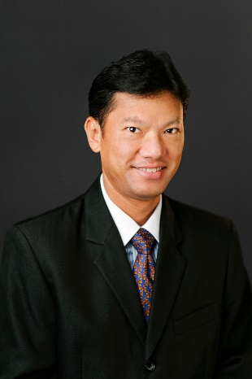Dr. Loh Kai Chee is an Associate Professor at NUS Department of Chemical and Biomolecular Engineering. He obtained his PhD in Biochemical Engineering from MIT and BEng in Chemical Engineering from NUS. His research interests are in biological transformation of wastes to energy and environmental biotechnology for waste water treatment. He teaches principally in biologics and pharmaceuticals manufacturing upstream and downstream processes. Dr. Loh is very passionate about education and has received more than 20 teaching awards, including being inducted into the University Annual Teaching Excellence Award Honour Roll and the Faculty’s Engineering Educator Award Honour Roll.